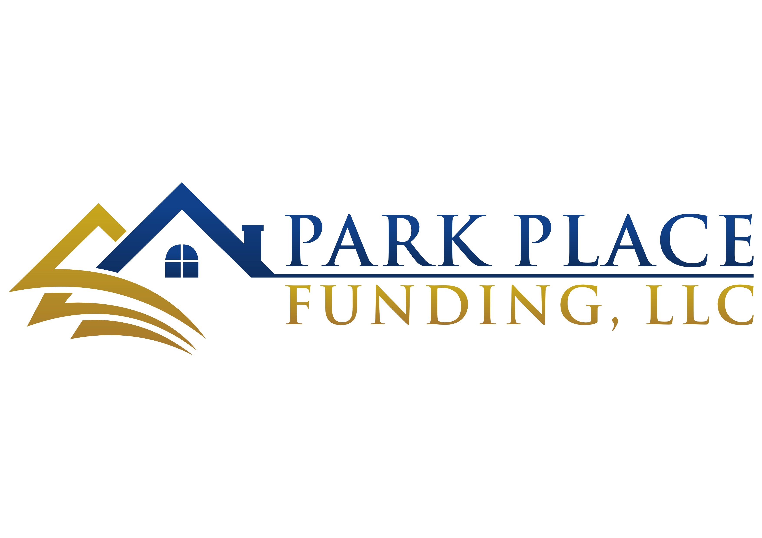
HARD MONEY LOANS

Thank you for letting us partner with you to build your investment! Want to continue building your goals?
Read to learn more about our returning investor program.

Amplified Investments Program

Join our loyalty program to amplify your empire
through higher loan amounts and decreased costs!

Rewards

- No higher interest rate
- No adjustable interest rate
- No absurdly high refinance fess
- No fee name changes

Why Should I Join?

Your loan will only cost 1% of the origination cost on every THIRD Hard Money Loan you borrow.
Meaning—you would save $3,000 on a $100,000 loan!

Take advantage of this offer and contact us right away!
Park Place funding is at your service to make all
your investment dreams possible.
Your Local Hard Money Loan Provider

Mike Colaninni
512-522-5055
Park Place Funding, LLC
Website

